**/*Roll No : 3002**

**Program Name : Write a program to demonstrate the** **required field**

**validator.**\*/

**Defualt.aspx :-**

<%@ Page Language="C#" AutoEventWireup="true" CodeFile="Default.aspx.cs" Inherits="_Default" %>

<!DOCTYPE html PUBLIC "-//W3C//DTD XHTML 1.0 Transitional//EN" "http://www.w3.org/TR/xhtml1/DTD/xhtml1-transitional.dtd">

<html xmlns="http://www.w3.org/1999/xhtml">

<head runat="server">

<title>Untitled Page</title>

</head>

<body>

<form id="form1" runat="server">

<div>

<asp:TextBox ID="textBox1" runat="server"></asp:TextBox>

<asp:RequiredFieldValidator ID="RequiredFieldValidatorl" runat="server" ErrorMessage="Required!" ControlToValidate="TextBox1"></asp:RequiredFieldValidator>

<asp:Button ID="button1" runat="server" text="submit" CausesValidation="true" />

</div>

</form>

</body>

</html>

**Output :-**

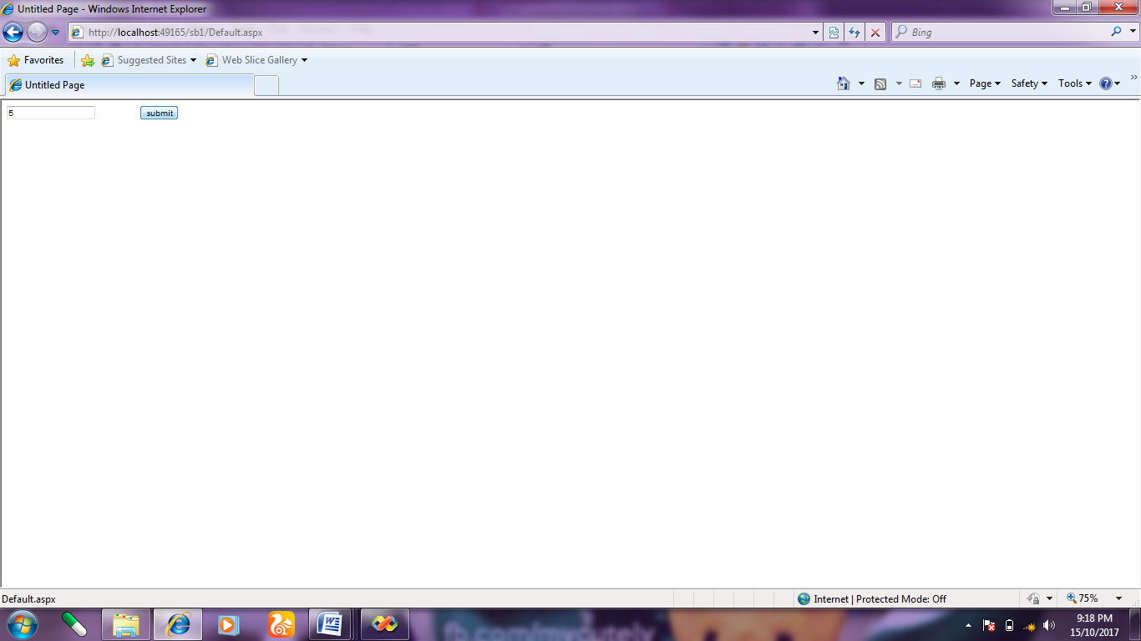

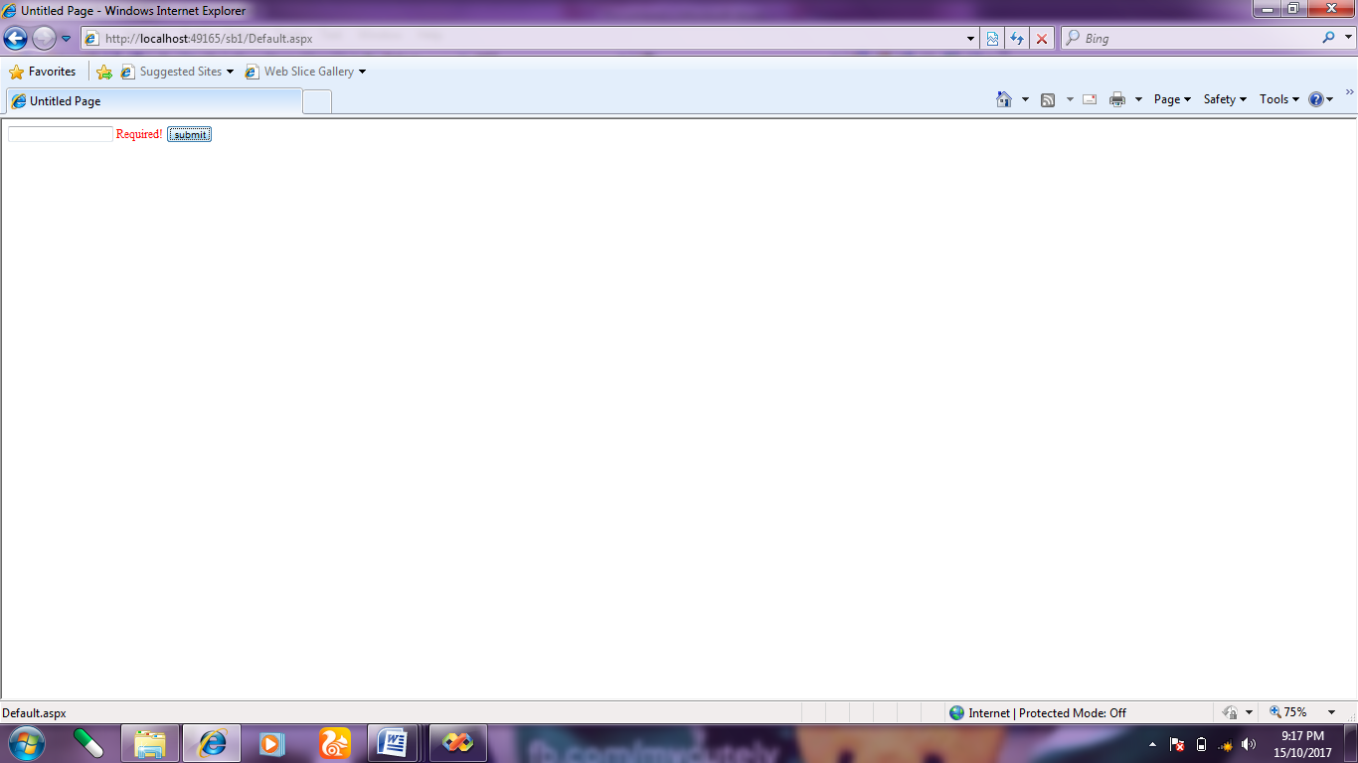

**/*Roll No : 3002**

**Program Name : Write a program compare validator server.**\*/

**Defualt.aspx :-**

<%@ Page Language="C#" AutoEventWireup="true" CodeFile="Default.aspx.cs" Inherits="_Default" %>

<!DOCTYPE html PUBLIC "-//W3C//DTD XHTML 1.0 Transitional//EN" "http://www.w3.org/TR/xhtml1/DTD/xhtml1-transitional.dtd">

<html xmlns="http://www.w3.org/1999/xhtml">

<head runat="server">

<title>Untitled Page</title>

</head>

<body>

<form id="form1" runat="server">

<div>

<table>

<tr>

<td>

<asp:Label ID="Label2" runat="server" Text="confirm password"></asp:Label>

</td>

<td>

<asp:TextBox ID="TextBox2" TextMode="Password" runat="server"></asp:TextBox>

</td>

</tr>

<tr>

<td>

<asp:Label ID="Lable2" runat="server" Text="confirm password"></asp:Label>

</td>

<td>

<asp:TextBox ID="textbox3" TextMode="Password" runat="server"></asp:TextBox>

</td>

</tr>

<tr>

<td>

<asp:Button ID="button2" runat="server" Text="Login" />

</td>

</tr>

</table>

<asp:CompareValidator ID="compareValidatorl" runat="server"

ErrorMessage="passwords don't Match!" ControlToValidate="textBox3" ControlToCompare="textbox2"></asp:CompareValidator>

</div>

</form>

</body>

</html>

**Output :-**

**1}Same Passwords :-**

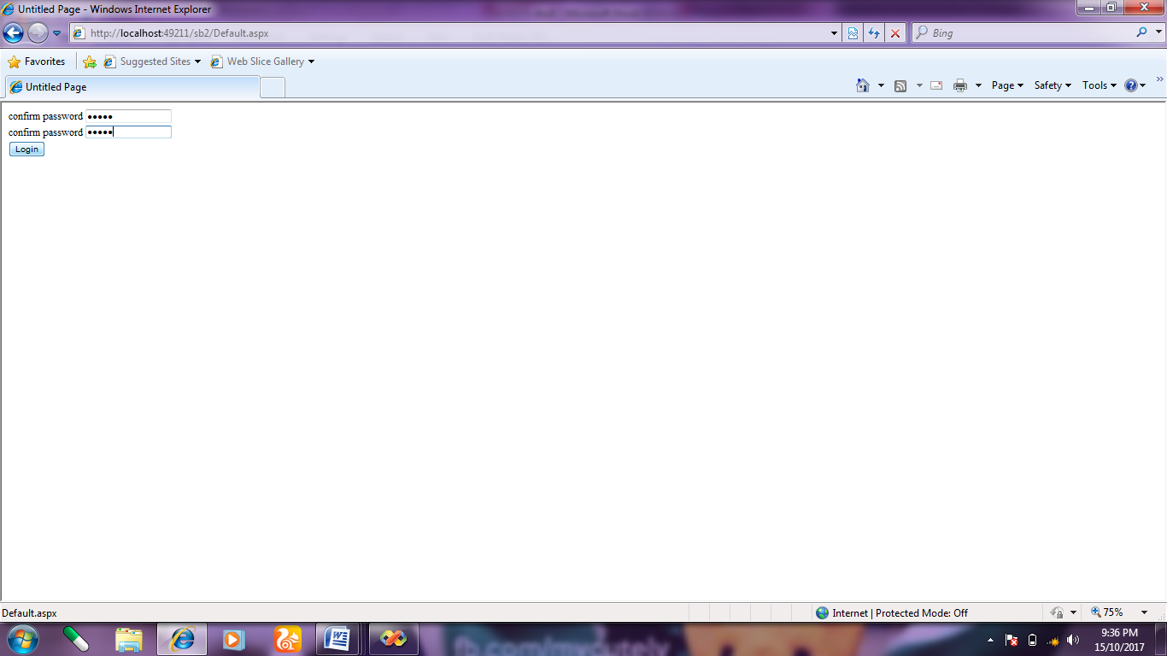

**2}Different Passwords :-**

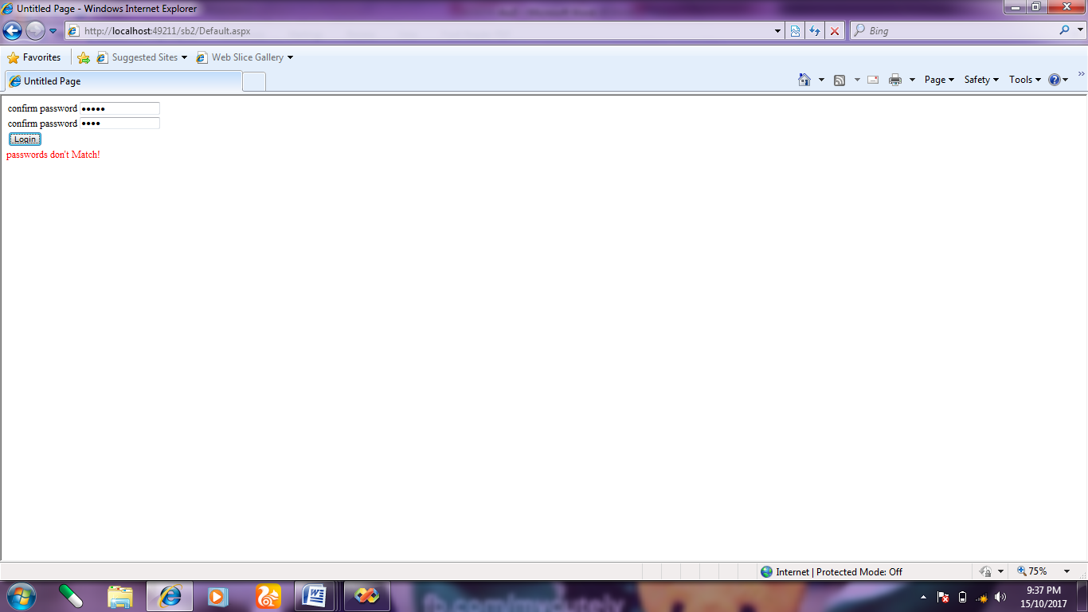

**/*Roll No : 3002**

**Program Name : Write a program Range validator server control.**\*/

**Defualt.aspx :-**

<%@ Page Language="C#" AutoEventWireup="true" CodeFile="Default.aspx.cs" Inherits="_Default" %>

<!DOCTYPE html PUBLIC "-//W3C//DTD XHTML 1.0 Transitional//EN" "http://www.w3.org/TR/xhtml1/DTD/xhtml1-transitional.dtd">

<html xmlns="http://www.w3.org/1999/xhtml">

<head runat="server">

<title>Untitled Page</title>

</head>

<body>

<form id="form1" runat="server">

<div>

<asp:TextBox ID="RangeTextbox" runat="server"></asp:TextBox>

&nbsp;&nbsp;&nbsp;&nbsp;&nbsp;&nbsp;&nbsp;

<asp:RangeValidator ID="RangeValidator1" runat="server"

ErrorMessage="Valid Marks" ControlToValidate="rangetextbox"

type="Integer" MinimumValue="0" MaximumValue="80"></asp:RangeValidator>

<br />

<br />

<br />

<asp:Button ID="CheckRange" runat="server" text="Marks" />

</div>

</form>

</body>

</html>

**Output :-**

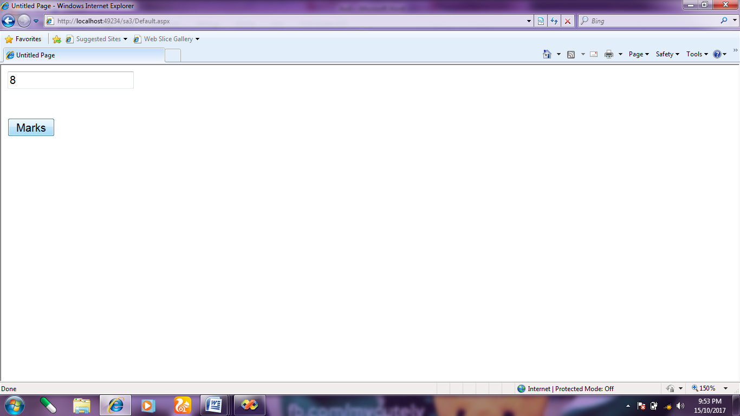

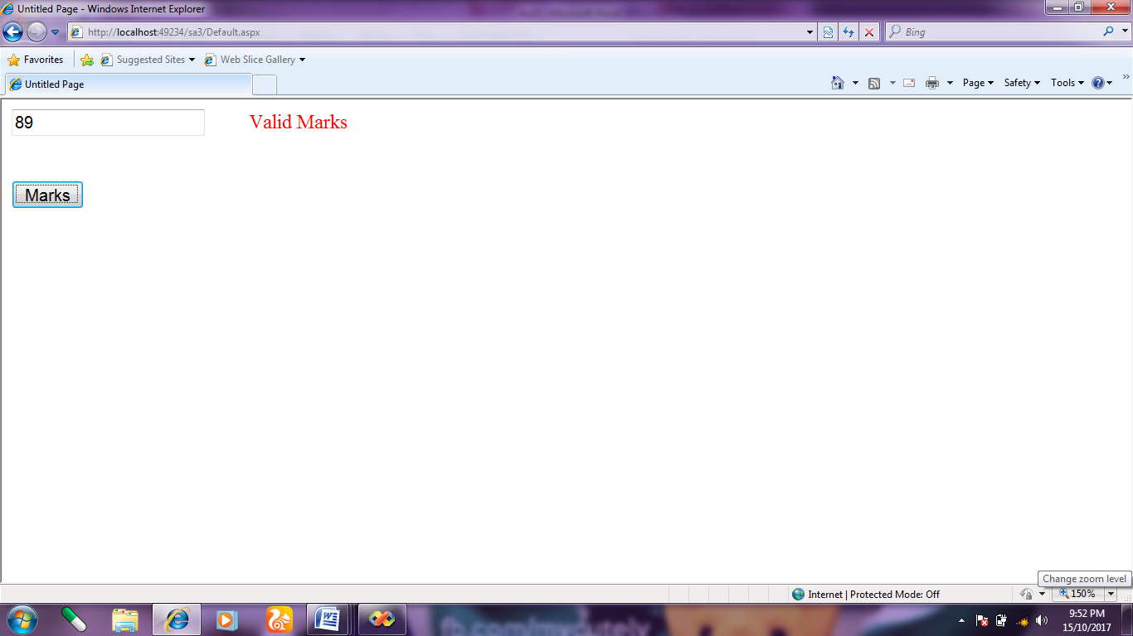

**/*Roll No : 3002**

**Program Name : Write a program Regular expression validator server**

**control.**\*/

**Defualt.aspx :-**

<%@ Page Language="C#" AutoEventWireup="true" CodeFile="Default.aspx.cs" Inherits="_Default" %>

<!DOCTYPE html PUBLIC "-//W3C//DTD XHTML 1.0 Transitional//EN" "http://www.w3.org/TR/xhtml1/DTD/xhtml1-transitional.dtd">

<html xmlns="http://www.w3.org/1999/xhtml">

<head runat="server">

<title>Untitled Page</title>

</head>

<body>

<form id="form1" runat="server">

<div>

<asp:TextBox ID="TextBox4" runat="server"></asp:TextBox>

<asp:RegularExpressionValidator ID="RegularExpressionValidator1" ControlToValidate="Textbox4" runat="server" ErrorMessage="You must enter an email address" ValidationExpression="\w+([- +]\w+)*@\w+([-]\w+)*\.\w+([-]\w+)*"></asp:RegularExpressionValidator>

<br />

<br />

<asp:Button ID="Button3" runat="server" Text="Check Mail" />

</div>

</form>

</body>

</html>

**Output :-**

**1}Correct Email- ID :-**

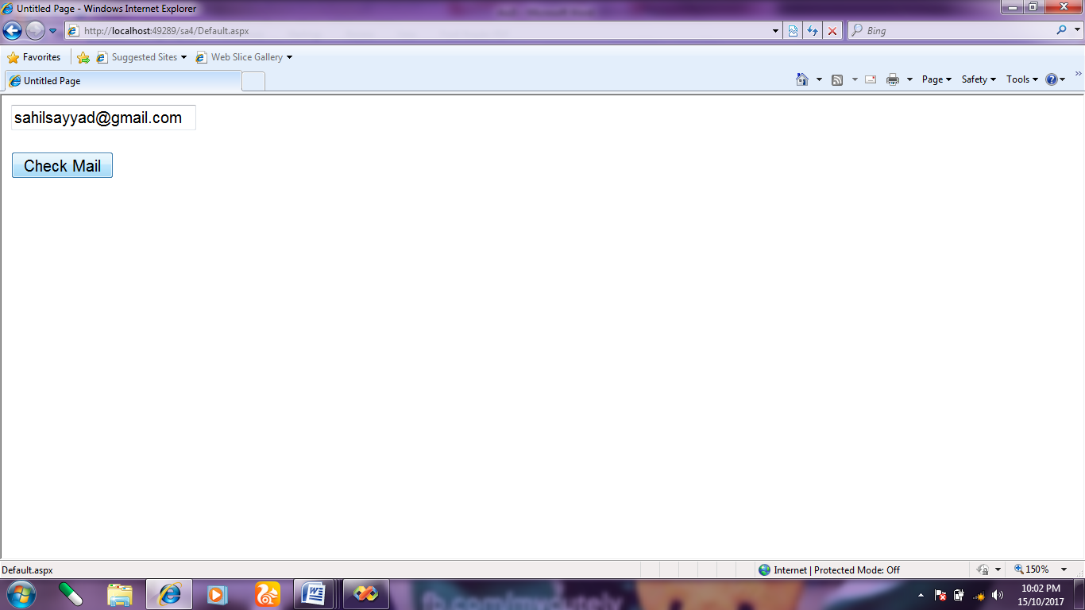

**2}Wrong Email -ID:-**

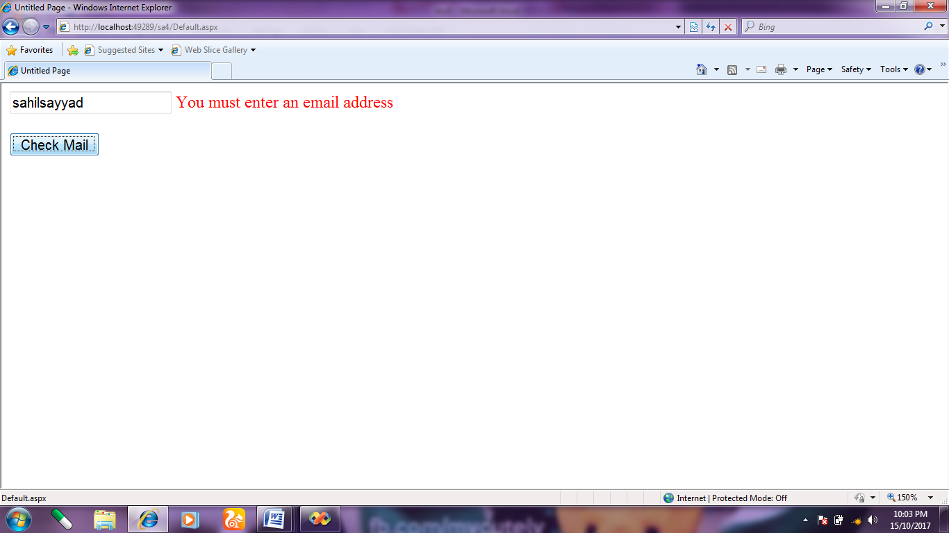

**/*Roll No : 3002**

**Program Name : Write a program Custom validator server control.**\*/

**Defualt.aspx :-**

<%@ Page Language="C#" AutoEventWireup="true" CodeFile="0504 CustomValidator.aspx.cs" Inherits="_0504_CustomValidator" %>

<!DOCTYPE html PUBLIC "-//W3C//DTD XHTML 1.0 Transitional//EN" "http://www.w3.org/TR/xhtml1/DTD/xhtml1-transitional.dtd">

<html xmlns="http://www.w3.org/1999/xhtml">

<head runat="server">

<title>Untitled Page</title>

</head>

<body>

<form id="form1" runat="server">

<div>

<asp:Panel ID="Panel1" runat="server">

<asp:Label ID="Label1" runat="server" Text="Enter even number-"></asp:Label>

<asp:TextBox ID="TextBox1" runat="server"></asp:TextBox>

<asp:CustomValidator ID="CustomValidator1" runat="server"

ControlToValidate="TextBox1" ErrorMessage="Plz enter even number"

onservervalidate="CustomValidator1_ServerValidate"></asp:CustomValidator>

<br />

<asp:Button ID="Button1" runat="server" Text="Submit" />

</asp:Panel>

</div>

</form>

</body>

</html>

**OUTPUT-**

1. Entering Even number-

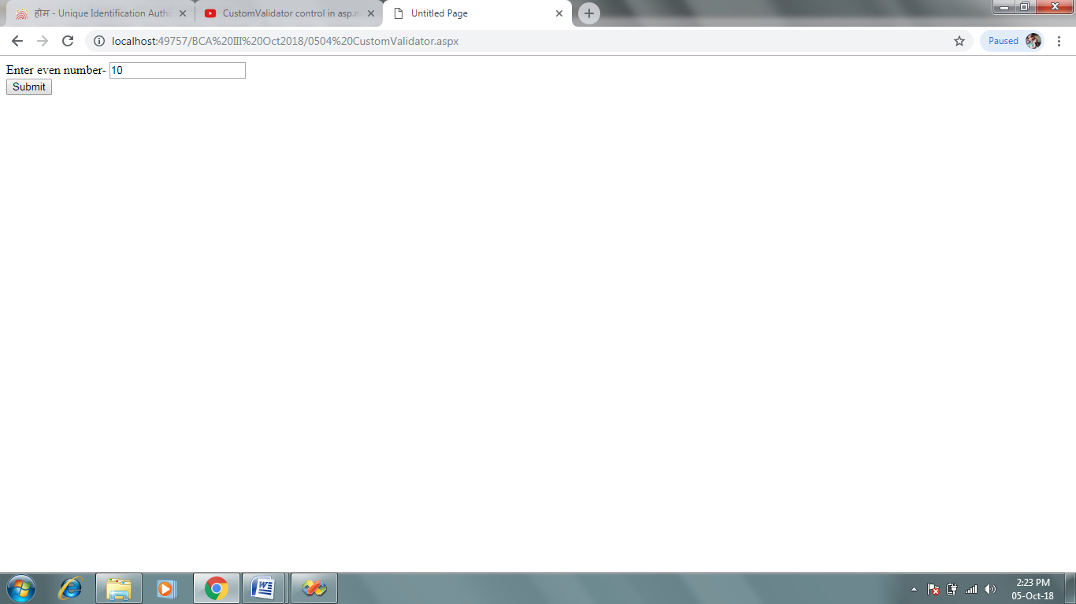

1. Entering Odd number-

